34th Annual Meeting of the European Society for the History of the Human Sciences (ESHHS) Travel Information

Location : Angers, France

Faculty of Languages, Humanities and Social Science, Université d’Angers,
11 bd Lavoisier, 49045, Cedex 01

Travel to Angers:

TGVs (France’s high speed railway line) link Angers with Paris’ Gare Montparnasse (1½ hours, frequent departures), arriving in Angers’ Gare Angers-St-Laud. Alternatively, one can take a direct train from Paris Charles de Gaulle (CDG) to Angers St. Laud train station; there are, as of now, 3 daily direct departures from the airport’s TGV train station near Terminal 2, leaving at 9:49 am and at 14:49 pm and 18:48 pm and taking about 2 hours and 20 minutes. If you arrive at Paris Airport Orly, you can take the Orlyval train to commuter train (RER) to the Denfert-Rochereau Station where you have a connection with the Metro Line 6- Direction Charles de Gaulle-Etoile. Exit the Métro at the Montparnasse Station to get a TGV to Angers St. Laud.

If you take the Eurostar from London to Paris, you arrive at Paris Gare du Nord Station and have to allow time to then travel by bus or taxi or metro to Paris Gare Montparnasse.

For detailed information on train schedules and tickets, see voyages-sncf.com.

The following website has useful information about Angers and the Loire Valley:
http://www.angersloiretourisme.com/en/angers-loire-valley-full-life/angers-loire-valley/welcome-angers-loire-valley/angers-tourist-office. It includes information for self-guided walking tours during your stay in Angers

NOTE: Every person entering France should be in possession of a valid passport and/or identification card. Some countries require a visa. Please contact the nearest French Embassy or Consulate near your home for further information. You can get detailed information from the web site of French Ministry of Foreign Affairs at: www.diplomatie.gouv.fr/en/coming-to-france/getting-a-visa/.

ACCOMODATIONS:

We recommend accommodation in the City Center also known as the “Hypercentre” as shown in the map below. Université d’Angers’ Faculty of Languages, Humanities and Social Science is outside the center but quickly accessible by the fast bus (line 4) see attached file (University bus stop “Lakanal”). There is also a slower bus (line 1) that goes to many places in the city center, but we recommend staying near the Chateau, or close the Boulevard du Roi René or the avenue Foch, all of which are on the bus n°4 route. Those of you who have already reserved a dorm will also be housed in the city center near the Chateau. If you are interested in the dorm option (Cité U) please contact Sharman Levinson slevinson.eshhs.eu if you haven’t already done so.

We also recommend the Hôtel Mercure Angers Centre-Gare, the Best Western Hôtel D’Anjou but any hotels along the bus route will be just as convenient.

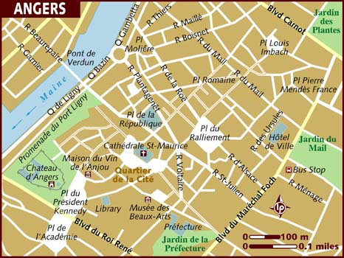

If you enjoy biking, there are many places to rent bicycles. The campus is about 7km from the center of town and there are some nice bike routes along the way.
Half way between the city center and the campus, inexpensive accommodation can also be found at the Hostellerie Le Bon Pasteur http://bonpasteur-hostellerie.org. But as there are almost no buses at night, you will have to either walk about twenty minutes back from evening activities in the city center, or bike back.

You will also find a larger bike map if you are interested in bike trips around Angers. http://www.angersloiremetropole.fr/fileadmin/alm/decouvrir/velo/plan-reseau-cyclable2013.pdf

ADDITIONAL INFORMATION:
Practical information

CLIMATE
The Conference will be held in summer. Weather could be variable and is usually mild (from warm to cool or some rain). Last year, the average temperature in July was a high of 25°C (77°F). You may wish to check http://www.accuweather.com/en/fr/angers/135974/weather-forecast/135974.

